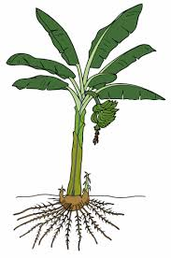
Endosymbiosis and Plastids Lab

- Obtain one ripe banana and one new banana. Describe the taste, feel, and/or smell of the bananas and the banana type that would taste best to you.
New banana | Ripe banana

- Take a piece of banana and perform an iodine test. Describe the differences. How do these differences relate to the taste of the bananas?

New banana | Ripe banana

- Where did the starch go when the banana changed from a new (raw) banana to being ripe?

- To view banana cells, simply rub some banana flesh on a slide and coverslip with iodine; a faint smudge of banana flesh will have ample cells for viewing. Draw each banana sample with 400x magnification
New banana | Ripe banana

- What is the difference between new (raw) banana cells and ripe banana cells?

- Are there chloroplasts in the banana cells? How can you tell whether chloroplasts are there?

- What is the function of chloroplasts, and would they be able to carry out that function in a banana cell? Which other areas of a plant might not be good at photosynthesis?

- Identify the iodine-stained subregions within the banana cells. Is the starch within an organelle or not?

- Banana seeds do not have chloroplasts (photosynthetic organelles in leaf cells), amyloplasts (starch-storing organelles in fruit cells), or chromoplasts (pigment-producing organelles in flower cells.) However, each of those organelles have their own DNA, and the DNA of chloroplasts, amyloplasts, and chromoplasts in a given banana tree is genetically identical. How does a banana tree produce tissues with these different plastids?

- How can a banana make starch (and cellulose), if it does not make glucose?

- Why is glucose transported and what is it for?

- Why is there so much chemical energy in bananas?

Handout written by Jon Darkow.

Readings
- Ftsz http://www.sciencedirect.com/science/article/pii/S0167488906000723
- Coral photosymbionts http://www.hhmi.org/biointeractive/coral-bleaching
- Summary of endosymbiosis evolution http://www.hhmi.org/biointeractive/coral-bleaching
- Zimorski, V., Ku, C., Martin, W. F., & Gould, S. B. (2014, 12). Endosymbiotic theory for organelle origins. Current Opinion in Microbiology, 22, 38-48. doi:10.1016/j.mib.2014.09.008

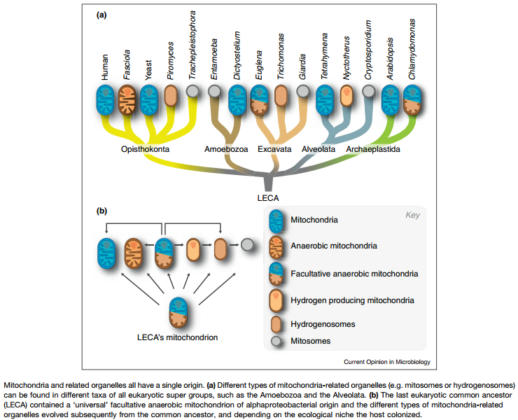

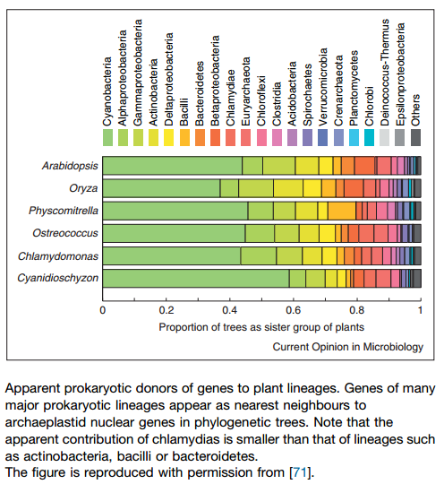

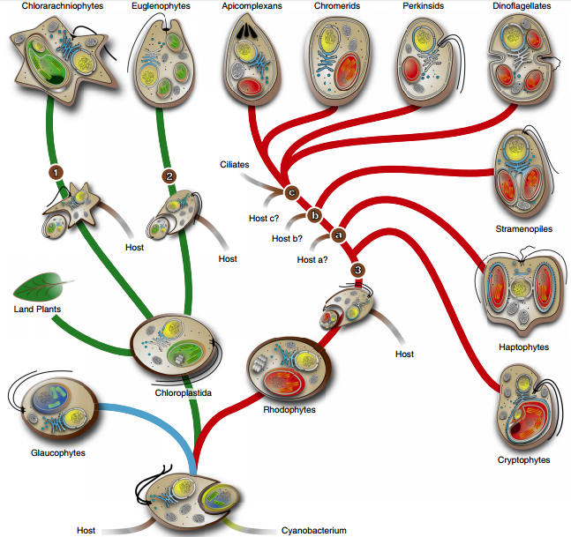
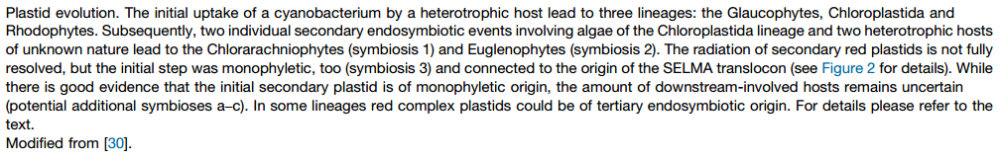
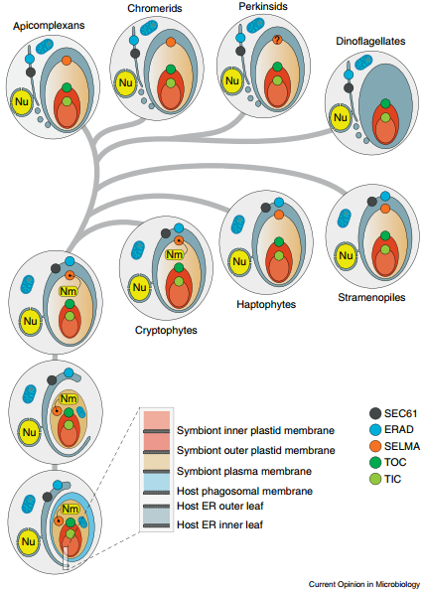
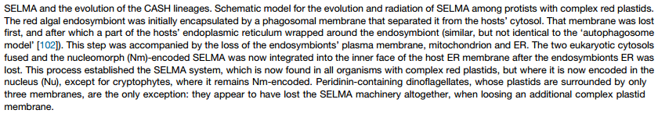
References
Tamarkin, D. A. (2015, 10). Exploring Carbohydrates with Bananas. The American Biology Teacher, 77(8), 620-623. doi:10.1525/abt.2015.77.8.9

